Wednesday 14th July

Dear Parents/Carers,

We encourage all children to take part in the Summer Reading Challenge during the holidays. It’s a really fun, worthwhile challenge that ensures your child continues to read over the long break, and to inspire them to have a lifelong love of reading. It would be wonderful if EVERY child in the school could participate. As part of their summer home learning, we have every expectation that they will visit the library during the holiday to borrow books.

The library service is a completely free service and there is no charge to become a member.
The opening times for Langport library are:
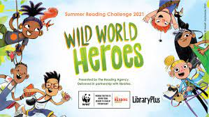
Monday 9.30am to 4.30pm
Tuesday 9.30am to 4.30pm
Wednesday Closed
Thursday 9.30am to 5pm
Friday 9.30am to 4.30pm
Saturday 9.30am to 12.30pm

Six books need to be borrowed and read over the course of the six week holiday in order to pass the summer reading challenge. The children’s certificates and medals will be given out in the first few weeks of school.

Please find out more about the challenge by asking at the library, or viewing this website: https://summerreadingchallenge.org.uk/

This year, Wild World Heroes, is launched on Saturday 10th July. The libraries have teamed up with WWF for a very special nature-themed Challenge that will inspire you to stand up for the planet!
Wild World Heroes will feature amazing books, awesome rewards, and plenty of ideas for taking care of our environment.

Happy Reading!

Miss Chadbourne

