What is the school doing to PREVENT extremism & radicalisation?



All members of the school staff have received specific training from an accredited Prevent trainer.

Children are encouraged to explore ideas of community, belonging and tolerance during PSHE lessons.

Issues in world news are discussed with the children in an age appropriate and open fashion, allowing children to discuss different points of view and ideas.

We have updated our safeguarding procedures to reflect statutory requirements in the Section 26 of the Government’s Counter-Terrorism and Security Act 2015.

We have direct contact with the Local Prevent Project Officer and other external professionals to receive on-going support and two way communication.

Where can I get support?



The school website has dedicated pages for safeguarding and school policies.

Who should I contact if I have a concern?

For high risk Prevent enquiries or emergencies:

**Tel: 999**

For low risk or non-emergencies speak to the school’s Designated Safeguarding Leads:

Mrs Tiffany Doughty Davis

Tel: 01458 250673

Email: [office@](mailto:office@)HEPS.ppat365.org

Or, in her absence:

Miss Jenny Chadbourne

Tel: 01458 250673

Email: [office@HEPS.ppat365.org](mailto:office@HEPS.ppat365.org)

Or Tel: 101 and ask for the Local Policing Team.

The Anti-Terrorist Hotline on Tel: 0800 789 321.

**A Parents’ Guide to**

**PREVENTing**

**Extremism**

**and**

**Radicalisation**



**HUISH EPISCOPI**

**PRIMARY SCHOOL**

**SAFEGUARDING CHILDREN**

“*Education is the most powerful weapon which you can use to change the world*.”

(*Nelson Mandela*)

Should I be worried?

Incidents of extremism and radicalisation are rare and as such when they do occur, make the news. As with all safeguarding issues, it is important to be vigilant, and not complacent, but also not to panic.

This guide will give you the information to make informed decisions and help safeguard your child.

What is extremism and radicalisation?

Prevent defines extremism as: “***vocal or active opposition to fundamental British values, including democracy, the rule of law, individual liberty and mutual respect and tolerance of different faiths and beliefs. We also include in our definition of extremism calls for the death of members of our armed forces***.”

Radicalisation is defined by the UK Government within this context as “***the process by which a person comes to support terrorism and extremist ideologies associated with terrorist groups.”***

What is extremism and radicalisation is not!

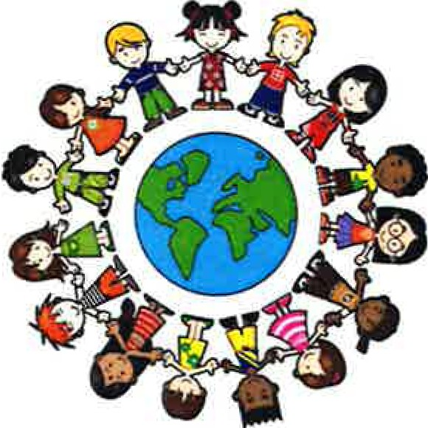

We live in a wonderfully diverse world, with both differences and similarities to celebrate. Exploring religious and different social beliefs, in a peaceful and non-violent way, is part of growing up and should not be confused with something more sinister.

The best way to PREVENT extremism and radicalisation is by open discussion and increased understanding of each other.

“*Peace cannot be kept by force; it can only be achieved by understanding*.”

(*Albert Einstein*)

What can I do as a parent to help my child?



You know your child better than anybody else. Having open, honest conversations on a regular basis will allow your child to explore new ideas in a safe environment.

Talk to your child about their online viewing. Social media such as YouTube and Facebook can be used to groom children towards a certain point of view.

Discuss different points of view, concerns, topics in the news etc, to show your child that there is always more than one point of view.

Encourage your child to take an active part in their local community. This could be part of a sports club, social group, volunteering. Getting out, meeting and talking to people around you helps to understand and become part of a community.